CHAPTER THREE METHODOLOGY

3.1 INTRODUCTION
This chapter presents the methodological approach adopted in the design and development of the proposed system for harmonizing user privileges across multi-cloud platforms. The chapter provides a detailed explanation of the research design, system architecture, data collection procedures, data modeling techniques, algorithm design, system workflow, and evaluation methods.
The primary objective of this study is to develop a Python-based system capable of analyzing Identity and Access Management (IAM) configurations from AWS and Azure environments, identifying inconsistencies in user privileges, and generating harmonized recommendations that improve security and governance.
Unlike purely theoretical studies, this research emphasizes practical system development, ensuring that the proposed solution can be implemented and evaluated in a controlled environment.
It presents the detailed methodology used in designing and developing the proposed system for harmonizing user privileges across multi-cloud platforms. It explains the research design, system architecture, data collection methods, data modeling, algorithm design, system workflow, and evaluation techniques. The aim is to develop a Python-based system that can analyze Identity and Access Management (IAM) configurations from AWS and Azure, detect inconsistencies, and generate harmonized privilege recommendations.

3.2 RESEARCH DESIGN
This study adopts the Design Science Research (DSR) methodology. DSR is particularly suitable because it focuses on the creation and evaluation of artifacts designed to solve identified problems.
In the context of this research, the artifact is a functional privilege harmonization system.
Why Design Science Research is Appropriate
The choice of DSR is justified by the following:
- It addresses a real-world cybersecurity problem
- It involves design, development, and validation of a system
- It produces a working prototype, not just theoretical insight

3.2.1 The research process follows a structured progression:
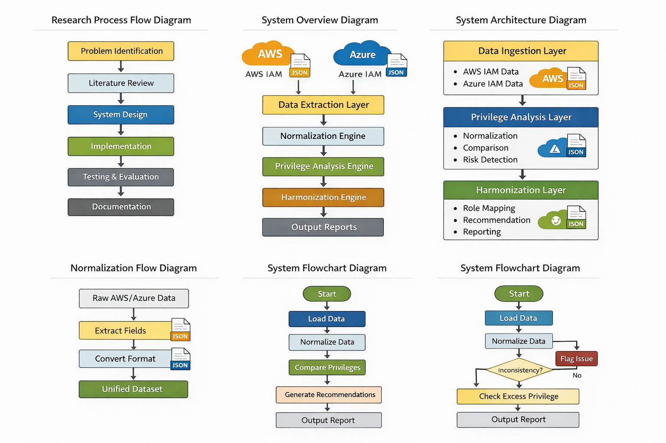
Figure 8: Research Process Flow Diagram (Created using ChatGPT)

3.3 SYSTEM OVERVIEW
The proposed system is designed to operate as an intelligent analysis tool that integrates IAM data from multiple cloud platforms and produces harmonized outputs.
Core Functional Objectives
The system performs the following key functions:
- Extraction of IAM data from AWS and Azure
- Transformation of heterogeneous IAM formats into a unified structure
- Cross-platform comparison of user privileges
- Detection of inconsistencies and excessive permissions
- Generation of harmonized recommendations

Figure 9: System overview (Created using ChatGPT)

3.4 PROPOSED SYSTEM ARICHITECTURE
The system adopts a three-layer architecture, designed to ensure modularity, scalability, and clarity of operations.

Figure 10: System architecture (Created using ChatGPT)

3.4.2 EXPLANATION OF ARCHITECTURE

1. Data Ingestion Layer
This layer is responsible for collecting IAM data from both AWS and Azure environments. It processes JSON files and extracts relevant entities such as users, roles, permissions, and policies.
- Privilege Analysis Layer
This is the core analytical component of the system. It converts raw data into a unified format and performs comparisons to detect inconsistencies, redundant permissions, and potential risks.
- Harmonization Layer
This layer ensures consistency across platforms by mapping equivalent roles and generating actionable recommendations. It also produces reports that can be used for decision-making.

3.5 DATA COLLECTION METHOD

3.5.1 DATA SOURCES
The system utilizes:
- Simulated AWS IAM datasets
- Simulated Azure RBAC datasets
These datasets are structured to reflect real-world IAM configurations while avoiding exposure to sensitive data.

3.5.2 DATA FORMAT
All data is stored in JSON format, which is widely used in cloud environments due to its flexibility and ease of parsing.

IAM Data Structure Representation
{
"User_ID": "U001",
"Platform": "AWS",
"Role": "Admin",
"Permission": "Full Access",
"Resource": "S3"
}

3.6 DATA MODELING AND NORMALIZATION

3.6.1 PROBLEM CONTEXT
AWS and Azure implement IAM using fundamentally different models:
- AWS → Policy-based
- Azure → Role-based
This creates incompatibility when attempting cross-platform analysis.

3.6.2 UNIFIED DATA MODEL
Field | Description
User_ID | Unique identifier
Platform | AWS / Azure
Role | Assigned role
Permission | Allowed action
Resource | Target resource

3.6.3 NORMALIZATION

The system uses a normalization flow by converting the data sets into a unified format that can be understood by the system which is the JSON format

Figure 11: Normalization flow (Created using ChatGPT)

3.7 SYSTEM ALGORITHM

3.7.1 ALGORITHM STEPS
- Load datasets
- Normalize IAM data
- Compare privileges
- Detect inconsistencies
- Identify excessive permissions
- Map equivalent roles
- Generate recommendations

3.7.2 LOGIC EXPLANATION
- If a user has different permissions across platforms → Inconsistency detected
- If a user has more permissions than required → Excess privilege risk
- If roles differ but represent similar access → Mapping required

3.7.3 PSEUDOCODE
BEGIN

LOAD AWS_data
LOAD Azure_data

NORMALIZE datasets

FOR each user IN dataset:

COMPARE permissions

IF permissions mismatch:
FLAG inconsistency

IF permissions exceed requirement:
FLAG excess privilege

MAP equivalent roles

GENERATE recommendations

OUTPUT report

END
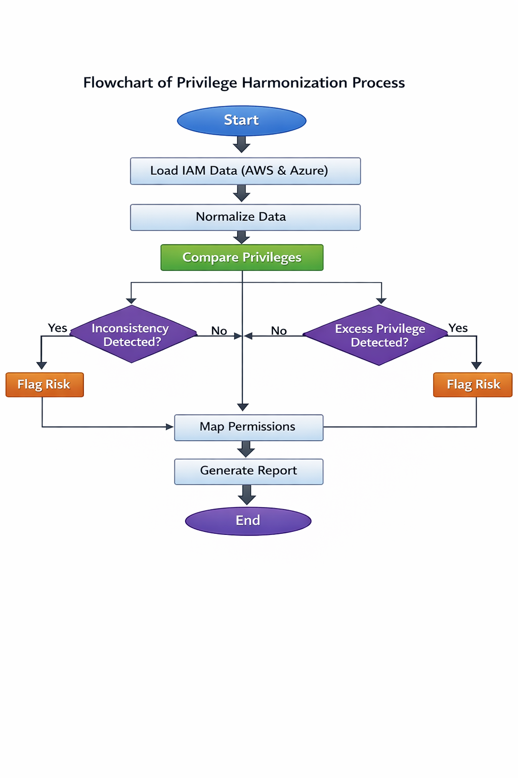
Figure 12: Flowchart diagram (Created using ChatGPT)

3.9 SYSTEM MODULES
The system is modular to improve maintainability and scalability.
Module Interaction Diagram
Data Loader → Normalization → Analysis → Harmonization → Reporting
Module Descriptions
- Data Loader Module: Handles ingestion of AWS and Azure IAM datasets
- Normalization Module: Converts heterogeneous data into a unified structure
- Analysis Module: Performs comparison and detects inconsistencies
- Harmonization Module: Maps equivalent permissions across platforms
- Reporting Module: Generates user-friendly output

3.10 TOOLS AND TECHNOLOGIES
- Programming Language: Python
- Development Tool: Visual Studio Code
- Libraries:
Pandas (data processing)
JSON (data parsing)

3.11 TESTING STRATEGY
The system undergoes multiple levels of testing:
Testing Workflow
Unit Testing → Integration Testing → System Testing
- Unit Testing: Tests individual modules
- Integration Testing: Ensures modules work together
- System Testing: Validates complete system performance

3.12 EVALUATION METRICS
- Accuracy
Measures correctness in detecting inconsistencies
- Efficiency
Evaluates processing speed
- Scalability
Assesses performance with large datasets

Evaluation Model
System Output → Compare with Expected Results → Measure Performance

3.13 ETHICAL CONSIDERATIONS
No real cloud credentials were used
- All datasets are simulated
- User privacy and data security are maintained
- The system is designed strictly for research purposes

3.14 LIMITATIONS
- No real-time cloud integration
- Limited to AWS and Azure
- Dependence on simulated datasets

